From Command Line
Log in to JDPD environment
Log into sqlplus
Type “@super” and hit enter. Follow prompts.
Exit JDPD
Type SID
Select Option 2 JDSP
Log into sqlplus
Type “@super” press enter and follow prompts.

**If can’t remember JDSP login
sqlplus / as sysdba

From UC4
Log into UC4 and click on Process Flows.

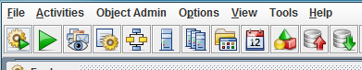

- Once selected click in the Search box in the bottom and enter ORA_SUPERUSER.
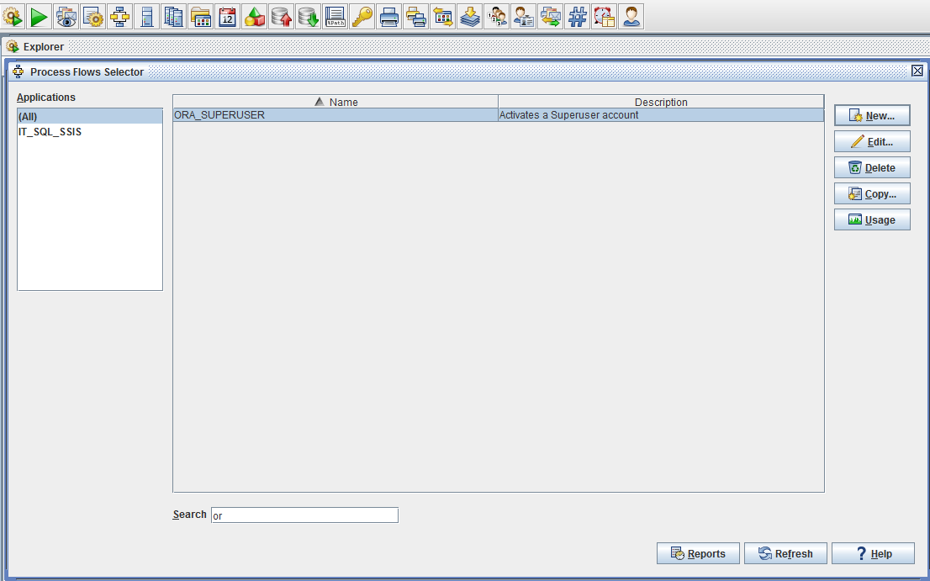

- Click Edit.
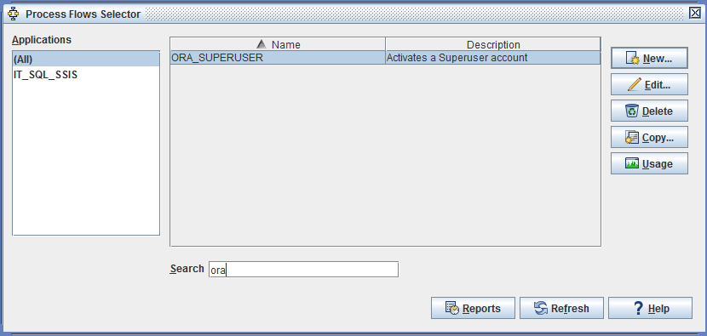

- Click on the Schedule tab.
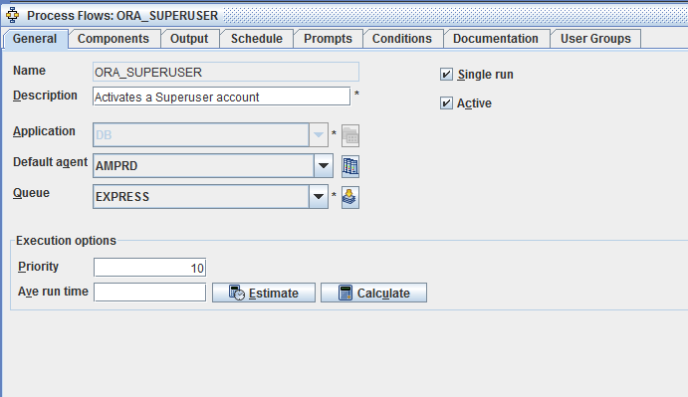

- Click Edit.
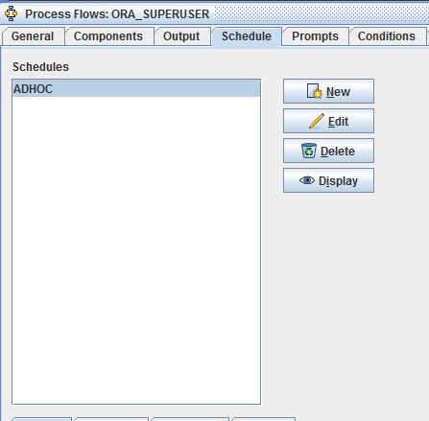

- Look at ticket, get the Date and Time referenced in the PDU and update the:
- Scheduled Start Date
- Scheduled End Date
- Start Times
Once complete click the Calculate button to make sure it is a valid schedule.
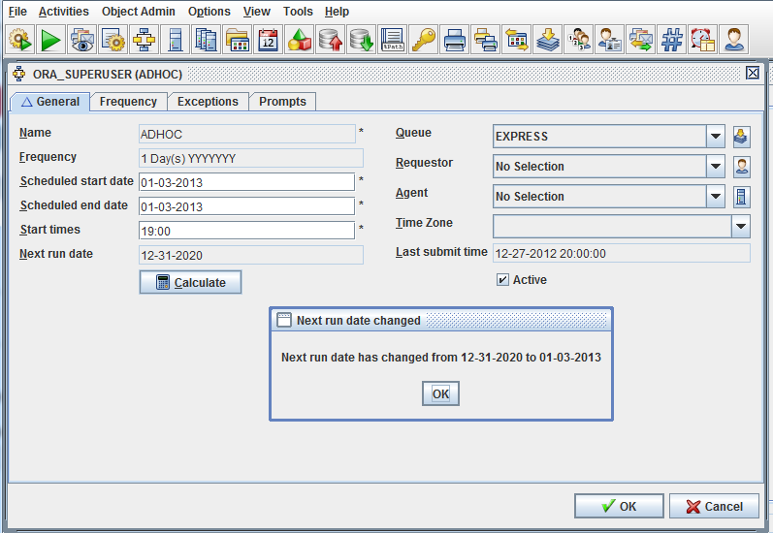

- If the next scheduled date is changed to the new date and time click OK.

- Next Click prompts tab:
- #1 and 2 never change as of right now as these are the only databases the UC4 job will run.
- #3 is the PDU number.
- #4 is the account (Always Upper Case and Make sure the name ends in ADMIN)
- #5 email address for the user this PDU is for and anyone else that should be notified.
For #5, you need to make sure that there are NO SPACES between email addresses otherwise the process will bomb.
email_address_1@plexus.com,email_address_2@plexus.com,email_address_3@plexus.com

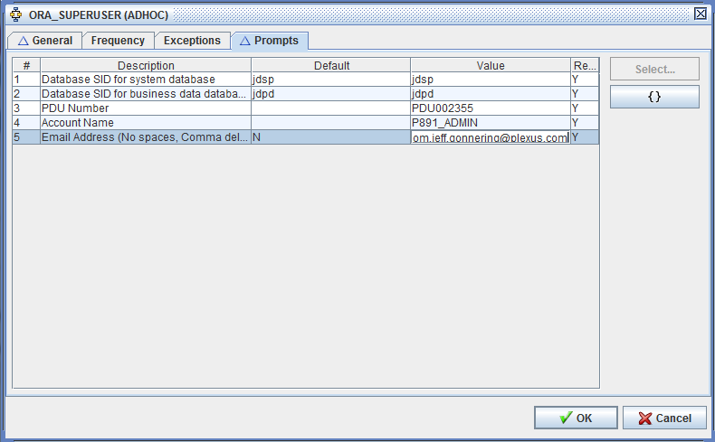

- Hit Ok to save the changes and then Hit OK again.

- To make sure the changes saved, go back into to review the changes to make sure they are there:
- Go to Schedule tab again and check the GENERAL tab to verify the schedule date / time.
- Go to the Prompts tab to verify the actual prompts.

